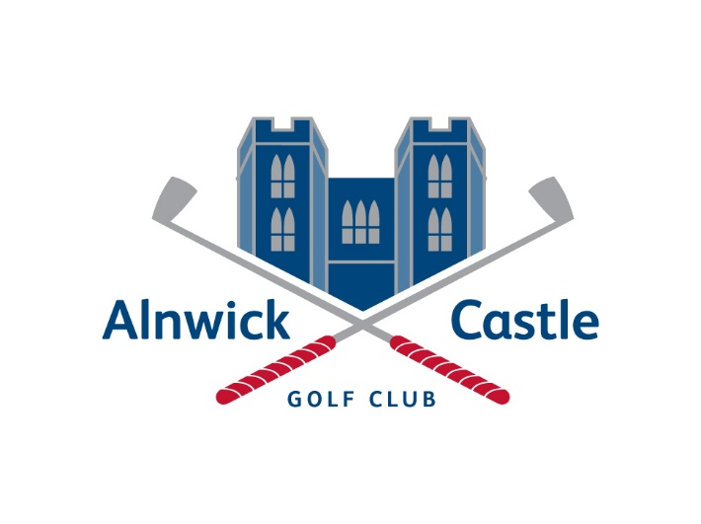
Terms and Conditions of Alnwick Castle Golf Club Ltd
- The following terms and conditions are applicable to all members of Alnwick Castle Golf Club
- By paying for an annual subscription you are deemed to have done so in the full and complete knowledge and acceptance of these terms and conditions.
- The terms and conditions, along with the contract, form the principle agreement between you and Alnwick Castle Golf Club. In signing the Terms & Conditions, the member is expected to comply with the Club Rules that are available for viewing on request. The company may sometimes need to make changes to the Club Rules. If we do this will, where reasonably possible, display notices in the Club notifying you of the change.
- Memberships are non-refundable and non- returnable- your membership allows you access to play golf on the course when a tee time is booked; to be included in club competitions you must pay the applicable entry fees.
- Alnwick Castle Golf Club reserve the right to limit the number of members in any given membership category.
- Alnwick Castle Golf Club reserve the right to remove a member who does not adhere to the members code of conduct.
- Alnwick Castle Golf Club reserves the right to ad or remove a membership category or change a membership category or subscription amounts associated with said subscription without prior notice.
- Data protection. You consent to our use of the information given by you, including your personal information for the administration of your membership. We will not pass any of your information to third parties.
- Renewal subscription payments are due on April 1st annually. Membership fees for the various categories are posted on Alnwick Castle Golf Club website.
- Subscriptions are payable by direct debit, cheque, credit card, debit card, or cash. Failure to pay the membership fee within one month will result in termination of membership, and to re-instate your membership an administration fee of £25 will be applicable.
- We will continue to take membership payments and will process Annual Direct Debits automatically at the start of each membership year unless otherwise notified.
- Alnwick Castle Golf Club reserves the right to use a debt collection agency to collect outstanding balances owed to them. Debt outstanding for over 30 days may be referred to a debt collection agency. A charge of £75 will be applied to the outstanding balance to cover the debt collection charges.
- Members introducing a guest must ensure the guest has paid the appropriate green fee. Any member having found to have introduced a guest that has not paid the relevant green fee will be in breach of these terms and conditions and may face disciplinary action or suspension.
- In the event of termination of membership or suspension within the membership year, there will no refund of membership subscriptions, unless there are exceptional medical grounds. The final decision on any refund will be granted lies with Alnwick Castle Golf Club Management. Any suspension of membership may only be granted upon sight of fully validated supporting medical documentation.
- Members and visitors must always adhere to the dress code, whilst on the golf course and within the clubhouse. See noticeboard for information.
- Members and visitors may be asked to produce evidence of their subscription/green fee or insurance whilst on the course by Alnwick Castle Golf Club staff – failure to do so may result in being asked to leave the course.
- Members and visitors are always expected to adhere to general golf course etiquette, whilst on the golf course i.e. raking bunkers, repairing pitch marks, slow play, shouting fore, keeping trolleys off tees/greens.
- Bad behaviour and the use of bad/foul language will not be tolerated whilst on the course or within the clubhouse. Failure to adhere to this may result in membership suspension/removal from the site.
- Alcohol is not permitted on the golf course unless as agreed.
- Members/visitors will be held liable for any costs incurred in repairs or replacements to any fixtures and fittings, property or equipment which has been deliberately, negligently or wantonly damaged, either within the clubhouse or on the course.
- Alnwick Castle Golf Club are not responsible for any loss or damage to members property whilst at the club.
- Members must have up-to-date insurance cover that protects against any damage or injury on the golf course and driving range, including third party cover.
- Alnwick Castle Golf Club will not discriminate against anyone on the grounds of race, sex, religion, age, disability or any other protected characteristic and will fully comply with obligations under the Equality Act 2010.
- Violation of any of these terms and conditions may result in disciplinary action and suspension/termination of membership.

